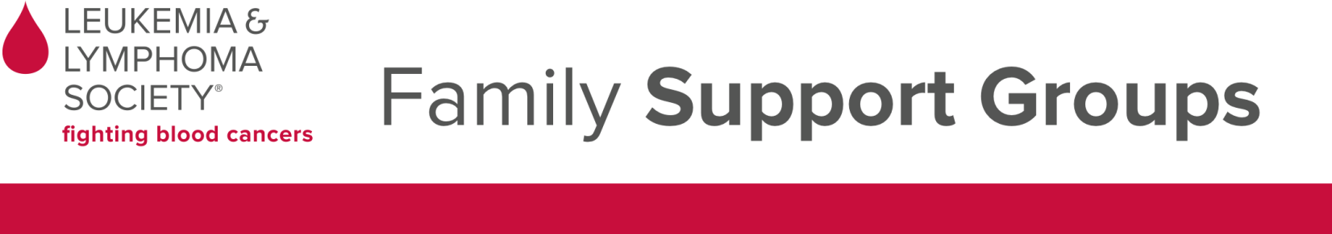
Wisconsin Chapter

Madison Area All Blood Cancers Group
Meets the 2nd Monday of each month 5:30-7:00 pm
Gilda’s Club Madison, 7907 UW Health Court, Middleton
Facilitators: Eva Allen, RN, BS, MSN, NP & Kristin Scheeler, MSSW, OSW-C
For more information, contact Gilda’s Club at 608-828-8880
Fox Valley Area All Blood Cancer Group
Meets the 3rd Monday of each month, 5:30-7:00 pm
Fox Valley Technical College, Room B130
Entrance 12, North Parking Lot, 1825 N. Bluemound Dr., Appleton
Light refreshments will be served
Facilitators: Carrie Olm, MSW, Noreen Voigt, RN, BSN, OCN and Carol Wolfgram, RN, BSN, OCN
For more information contact Carrie Olm at 920-831-8429 or colm@ascension.org
Milwaukee Area Leukemia, Lymphoma & Myeloma Group
Meets the 4th Wednesday of the month 5:30-7:00 pm
New Berlin Public Library: 15105 Library Lane, New Berlin, WI 53151
Facilitators: Kristen Kell, RN, BSN, OCN & Judy Cline, MSSW, OSW-C, Margaret Schweitzer, APNP & Linda Glaudell, MSW, LCSW, OSW-C
For more information, contact Josh Bollam at LLS at 914-821-8409 or josh.bollam@lls.org

Milwaukee Area Myeloproliferative Neoplasms Group
Meets quarterly from 1:00 - 2:30 p.m.
Froedtert’s Clinical Cancer Center - Conference Room J
The Clinical Cancer Center is located on the south side of the Froedtert & the Medical College of Wisconsin campus, across from Wisconsin Avenue
Facilitator: Lori Jemison, RN, ONC, BMTCN
For more information, contact Lori Jemison at 414-805-1254 or lori.jemison@froedtert.com

GROUPS WILL NOT MEET WHEN SCHOOLS ARE CLOSED DUE TO WEATHER.
GROUPS DO NOT MEET IN DECEMBER OR JULY.

One-on-one peer support is also available over the phone through our Patti Robinson Kauffman First Connection Program. Please call our Information Resource Center at 1-800-955-4572 to be matched with a trained peer volunteer.

