

**Are you a biotech company exploring personalized neoantigens?**

**If so, then we want to introduce you to an exciting funding opportunity in the blood cancer space.**

**Deadline for Inquiry Submission: November 1st 2018**

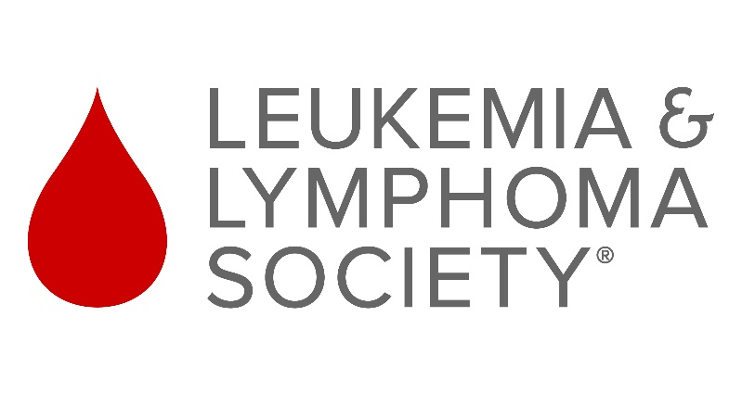

**TAP**

**Purpose: To support the identification, validation, and development of a novel neoantigen therapeutic approach to personalized medicine in specific heme/onc indications**

The Leukemia & Lymphoma Society (LLS) is the world’s largest voluntary (nonprofit) health organization dedicated to funding blood cancer research and providing education and patient services. The Therapy Acceleration Program (TAP) at LLS is a strategic program initiated 11 years to speed the development of therapies that have the potential to improve the standard of care for blood cancer patients, especially in areas of high unmet medical need. TAP funding is available up to $10M with co-funding provided by the company. Among >60 projects LLS TAP has supported, two therapies have gained regulatory approval and are saving lives every day: Vyxeos (Celator/Jazz) and Yescarta (Kite/Gilead).

LLS TAP recognizes that identifying and utilizing true personalized neoantigens could generate transformative treatments for blood cancer patients. For example treating early-stage CLL, MDS, MGUS & SMM patients with personalized neoantigen therapies might prevent transformation of these diseases to more aggressive types. LLS TAP sincerely invites your company to submit a funding request for discovering and developing innovative neoantigen based therapies in the blood cancer space.

Though typical TAP funding focuses on clinical studies, TAP will consider funding requests that may include the following stages but must include stage 4 (clinical component):

1. Identification of personalized neoantigens in a defined heme/onc patient population
2. Validation of identified neoantigens (ability to induce robust immune responses)
3. Development of a modality engaging the neoantigens
4. Conducting a clinical POC study in the patient population defined earlier

To start the process, please fill out the inquiry form (available on the website) and email back with a non-confidential slide deck.

In order to be considered for funding please submit these by November 1st.

Thank you for your attention and we’re looking forward to hearing back from you!

LLS TAP Team